Screen Shot of R

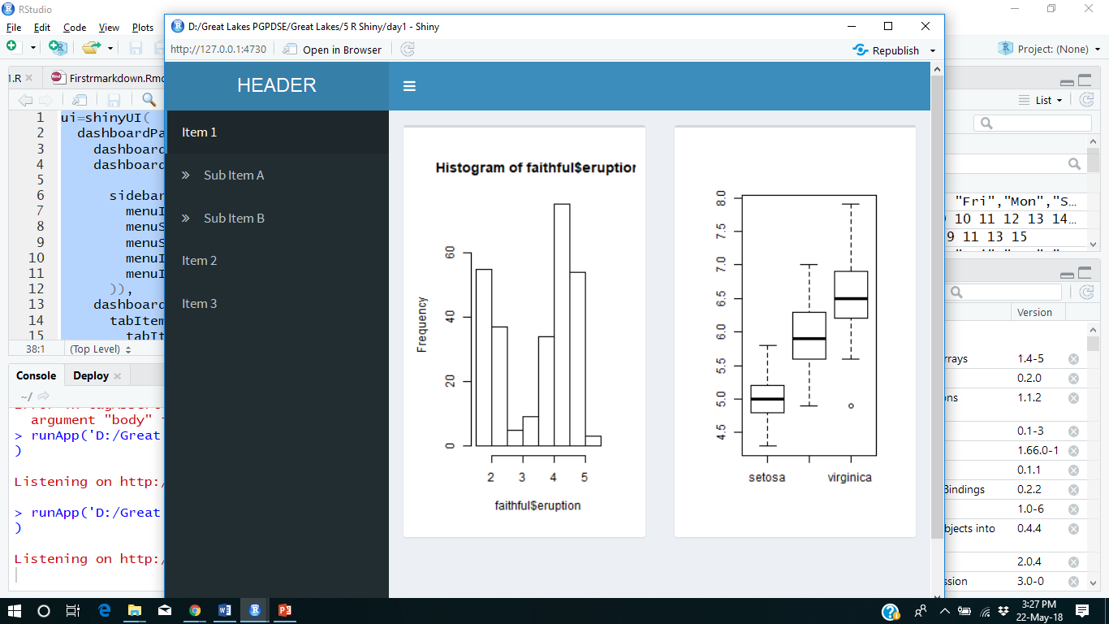

R Codes

ui=shinyUI(

dashboardPage(

dashboardHeader(title="HEADER"),

dashboardSidebar(

sidebarMenu(

menuItem("Item 1",tabName = "item1"),

menuSubItem("Sub Item A"),

menuSubItem("Sub Item B"),

menuItem("Item 2",tabName = "item2"),

menuItem("Item 3",tabName = "item3")

)),

dashboardBody(

tabItems(

tabItem(tabName = "item1",

fluidRow(

box(plotOutput("histogram")),

box(plotOutput("IRIS"))

)

),

tabItem(tabName = "item2",h1("DASHBOARD1")),

tabItem(tabName = "item3",h2("DASHBOARD2"))

)

)

)

)

server=function(input,output){

output$histogram=renderPlot({

hist(faithful$eruption)

})

output$IRIS=renderPlot({

plot(iris$Species,iris$Sepal.Length)

})

}

shinyApp(ui,server)